**Chatbot To Shop For Essentials During Pandemic Using Watson Assistant**

Introduction

How do we keep people from hoarding essential items during a pandemic and a lockdown? How can people get essential items through a digital mode?

Today, because of social distancing and other issues it can be risky for some people to shop for essential in person. This code pattern helps with this issue by giving people an

online option to shop for essential items.

In this code pattern, learn how to build an AI-powered back end system that can take the daily essentials orders through an online mode. The system processes the incoming

text requests by converting them to formatted orders lists. Then, this system can be connected to the inventory database for optimizing supply chain management. This solution can be applied to various domains, such as ordering vegetables and ordering groceries.

Block Diagram

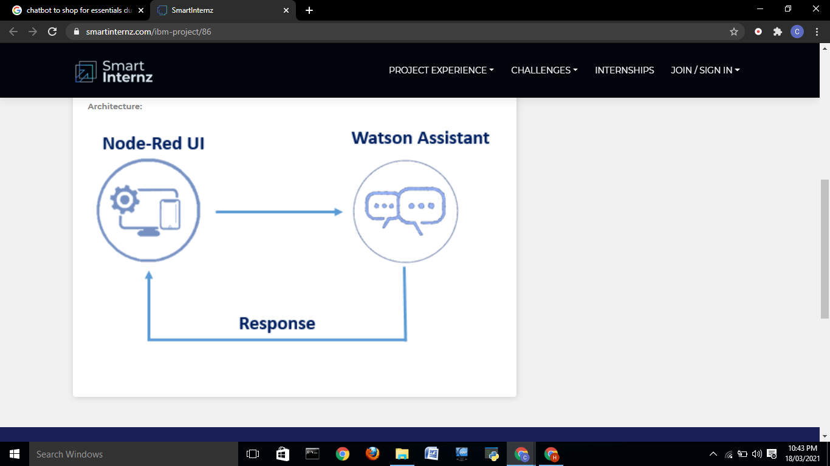

Setup Watson Assistant

● Create Watson Assistant service

● Create the skills

1. Create Action Skills

2. Create Dialog Skills

a. Create Intents

b. Create Entities

c. Use System Entities

d. Create Dialogs

Building Node-Red Application

● Create Node-Red Service

● Integrate Node Red To Assistant

Flow Chart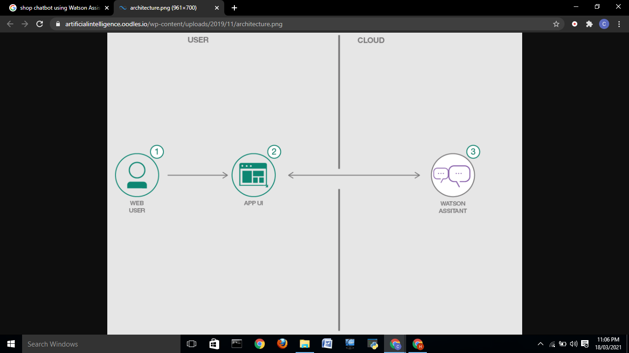

Result

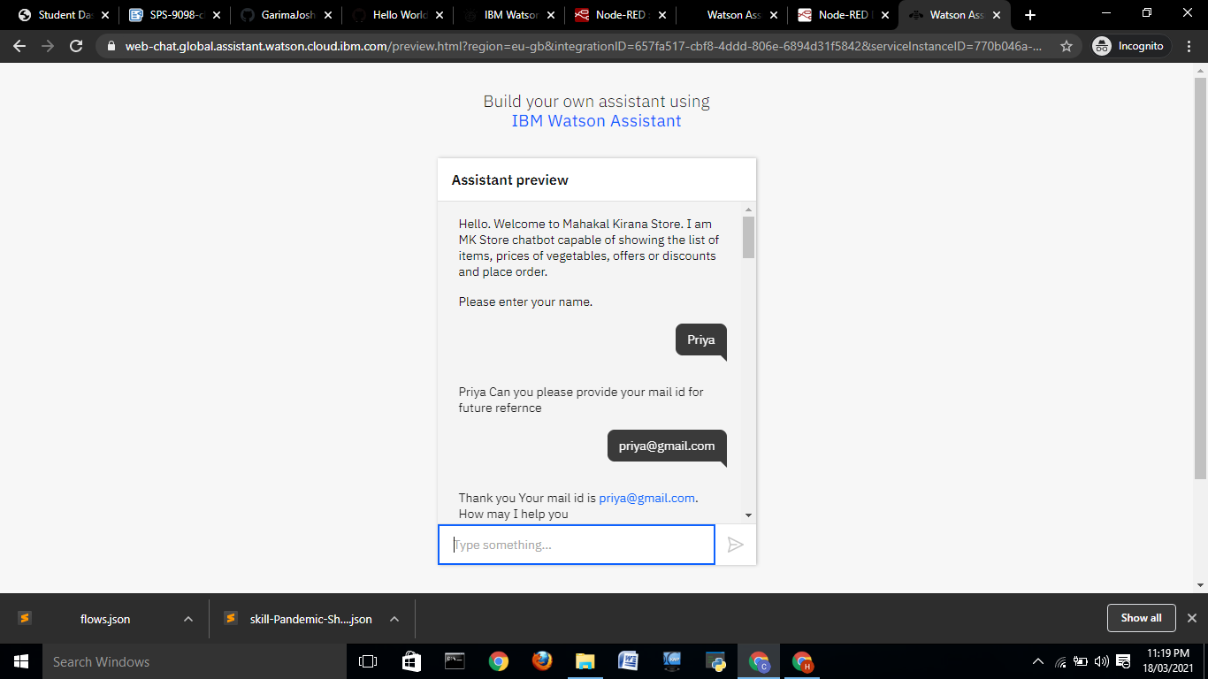 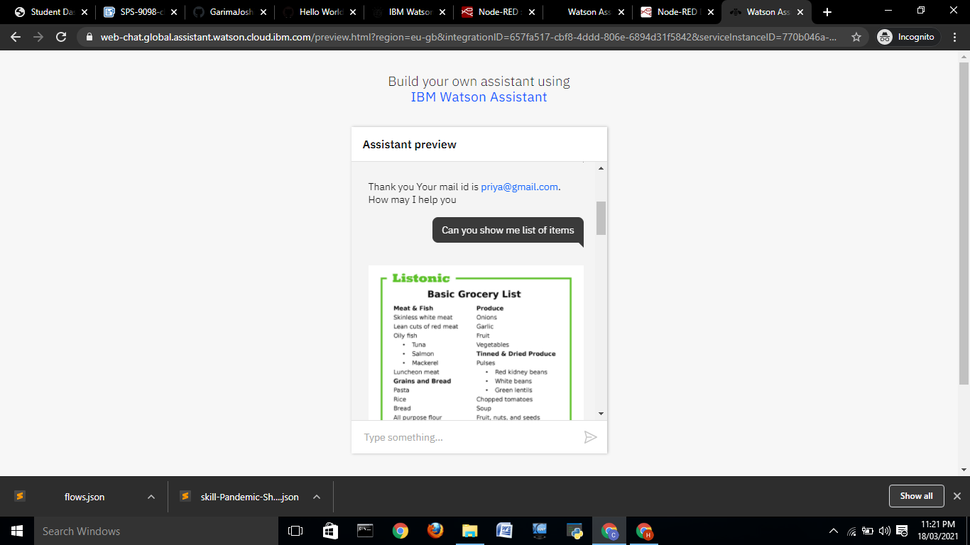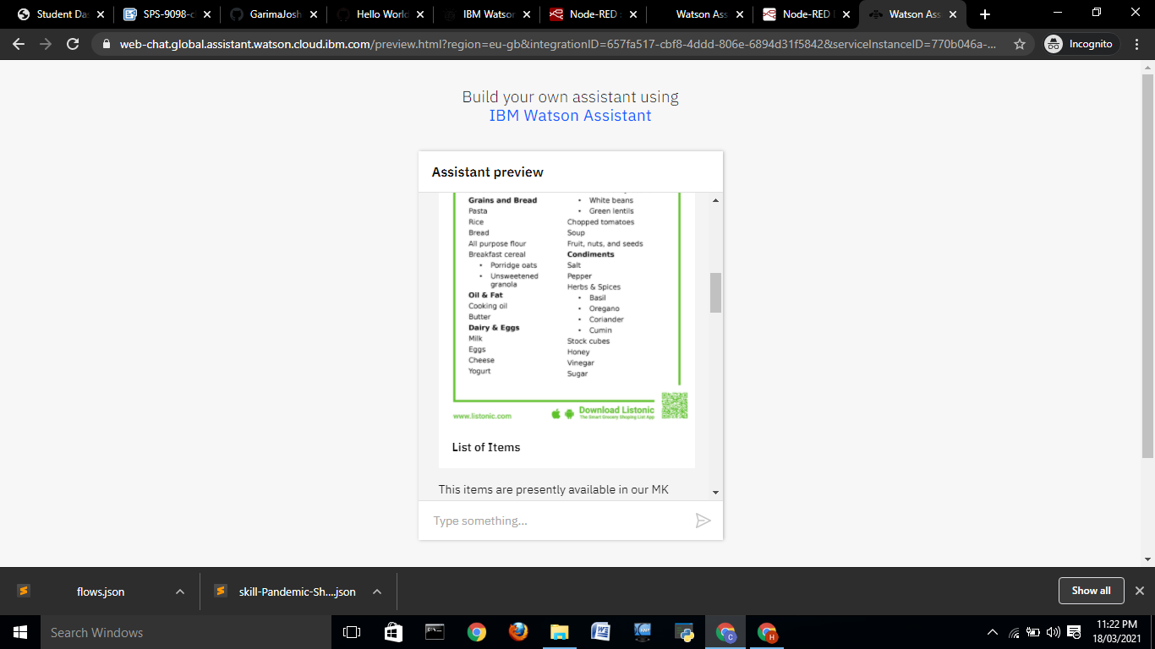 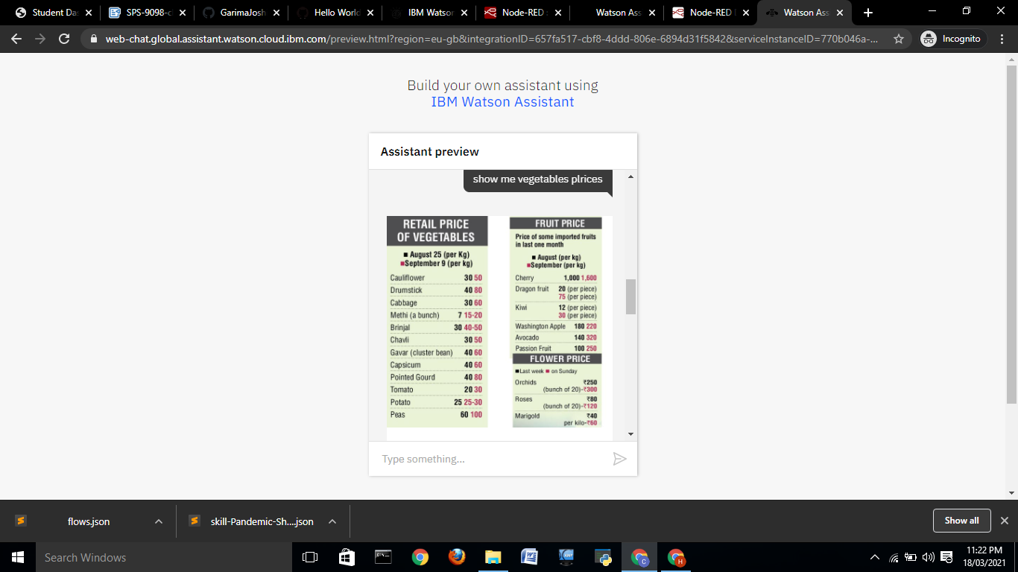 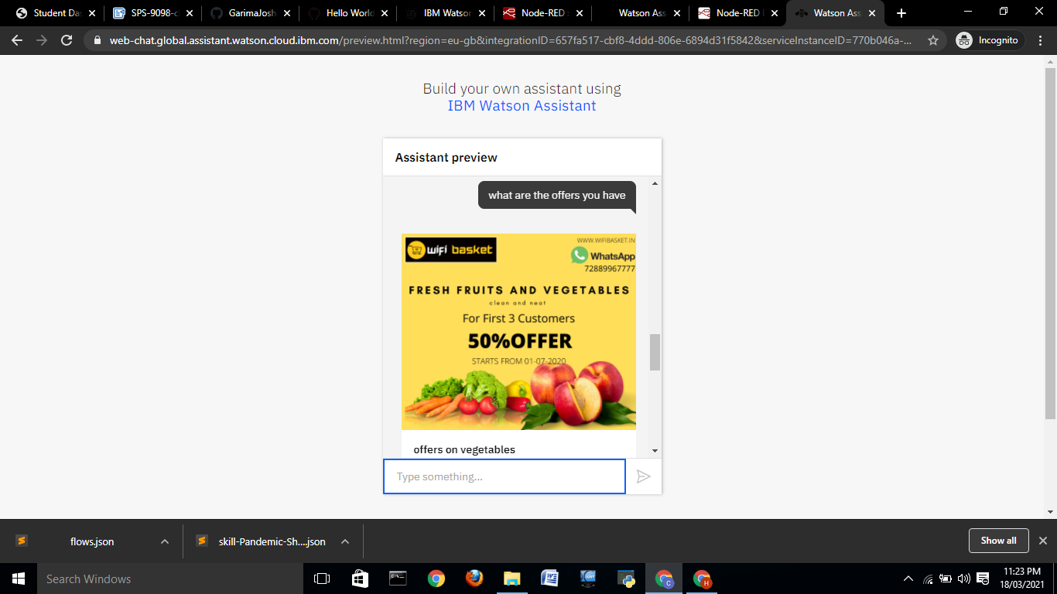 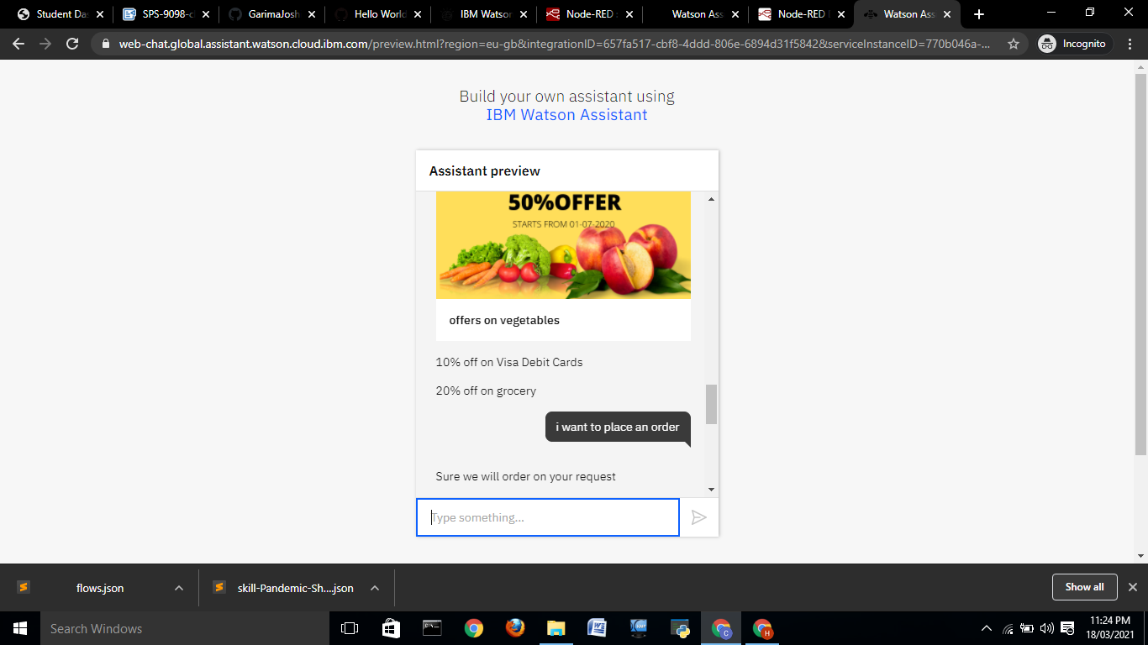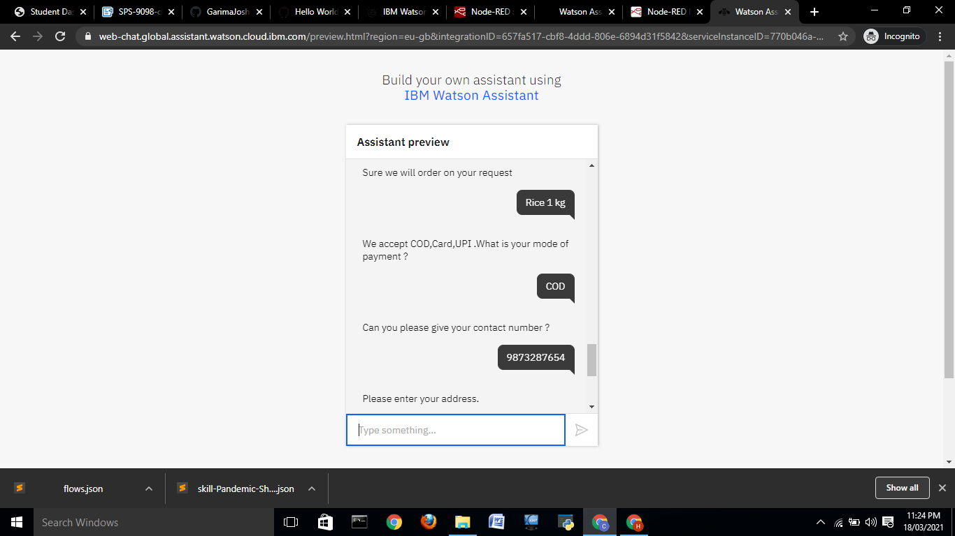 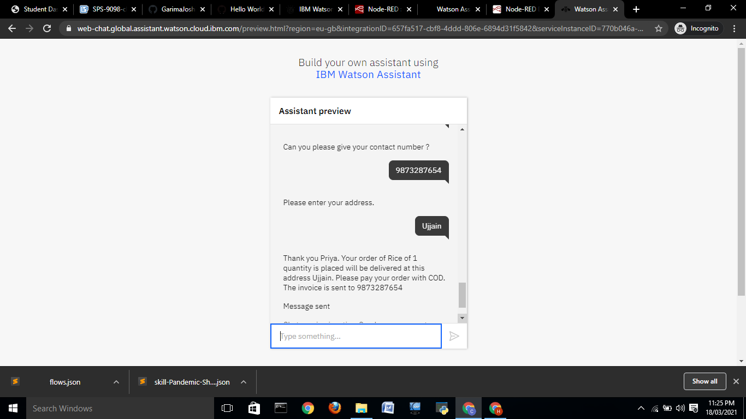

Node-Red Flow

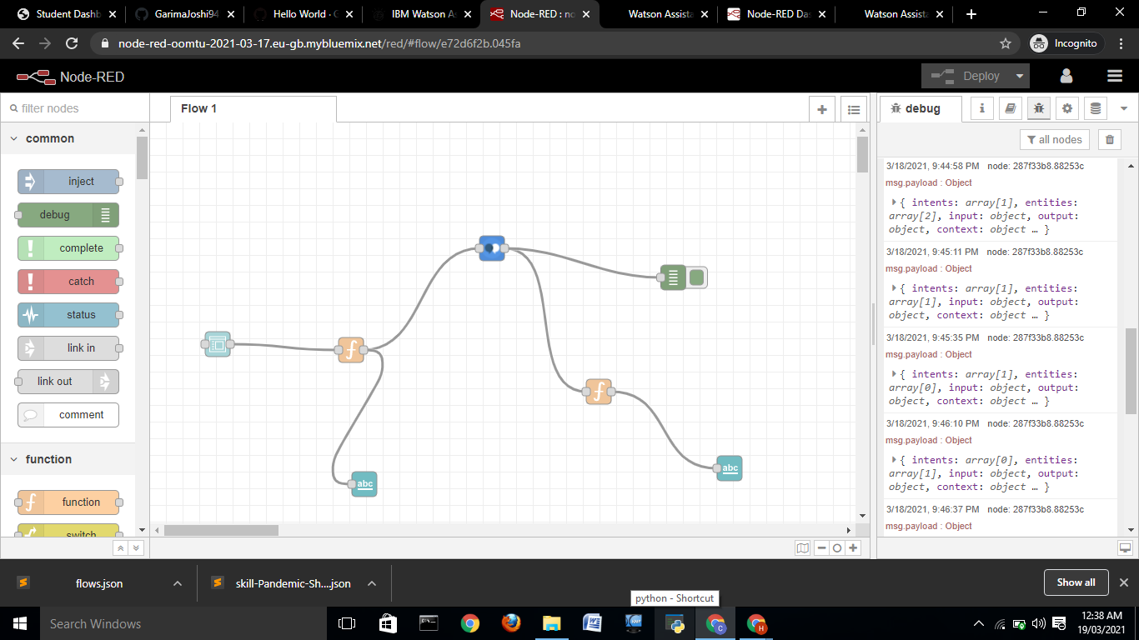

Node-Red Result

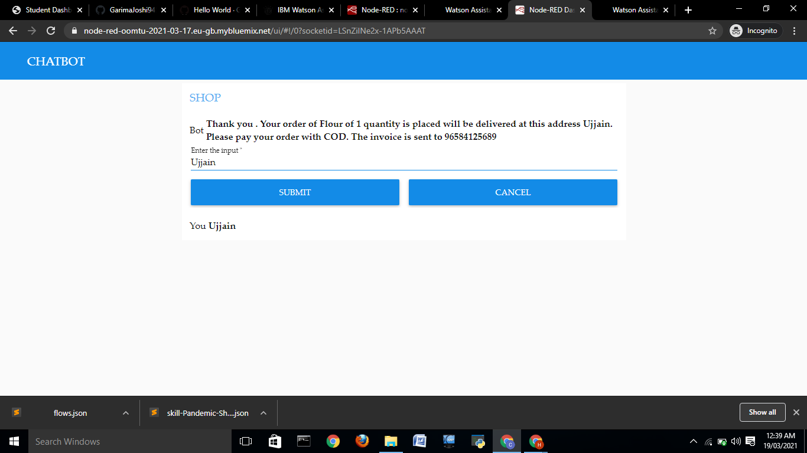

Advantages

● Gather Customer Insights

● Increase Sales

● Available 24/7

● Save Money

● Improve Customer Satisfaction

Disadvantages and Risks

● Lack Emotions

● Difficult to Create

● Made to Handle First-Level Question

● Require Maintenance

Applications

Chatbots are mainly used to answer customers’ questions.

However, there are still different types of chatbots that may be

used in different situations.

● Chatbots Answer Questions And Inquiries.

● Book Tickets To Events/Shows With Chatbots.

● Use Chatbots To Find Products, Check Inventory and

Recommend Items.

● Chatbots To Build Remarkable Customer Experience.

● Chatbots Can Process Return and Exchange Requests.

Conclusion

This course will teach you how to create useful chatbots without

the need to write any code. Leveraging IBM Watson&#39;s Natural

Language Processing capabilities, you&#39;ll learn how to plan,

implement, test, and deploy chatbots that delight your users,

rather than frustrate them. True to our promise of not requiring

any code, you&#39;ll learn how to visually create chatbots with Watson

Assistant (formerly Watson Conversation) and how to deploy

them on your own website through a handy WordPress plugin.

Don&#39;t have a website? No worries, one will be provided to you.

Chatbots are a hot topic in our industry and are about to go big.

New jobs requiring this specific skill are being added every day,

consultants demand premium rates, and the interest in chatbots is

quickly exploding. Gartner predicts that by 2020, 85% of customer

interactions with the enterprise will be through automated means

(that&#39;s chatbots and related technologies). Here is your chance to

learn this highly in demand set of skills with a gentle introduction

to the topic that leaves no stone unturned.

Future Scope

While voice interface may be optional, chatbots have been in the

enterprise long enough for developers and experts to begin

identifying what elements of chatbots are mainstay requirements.

NLP development, human-like conversational flexibility and 24/7

service are crucial to maintaining chatbots&#39; longevity in enterprise

settings. Chatbots are AI devices and, looking ahead, they need

to keep up with AI trends, such as automated machine learning,

easy system integration and developing intelligence.

Source - Smart Bridge training

Project Name - Chatbot To Shop For Essentials During

Pandemic Using Watson Assistant